**Introduction**

Seishun – A School Workspace

This project aims to create a digital workspace that students can rely on. This is a workspace where they can create notes from lessons, start to-do lists to keep track of their responsibilities, create a planner from their calendar, have a timer for their studying, create a space where they can keep track of their classes and instructors, and a simple calculator. The reason for this is to create an all-in-one workspace so that the students do not need to keep switching apps all the time, and can have everything they need in just one place. This can help them keep their school-related responsibilities organized.

**Project Requirements**

This project requires:

Experienced Developers

The project requires developers who are experienced in at least HTML and CSS. The workspace plans to be entirely web-based when released.

Inhouse Servers

Since the project will be web-based, we will need to have our own servers up and running 24/7 in order to avoid downtimes. This is because students may need to access the workspace at any time of the day.

Computers and gadgets

To develop this project, we need at least mid-range computers that can handle developing the workspace. This is also required to test out the functions before releasing it as an official version on the internet.

Accessibility over the internet

The workspace must function correctly in order to be accessible by the millions of students across the world. In order for them to access the workspace, they also must have internet connection and a computer/smartphone.

**Use-case diagram**

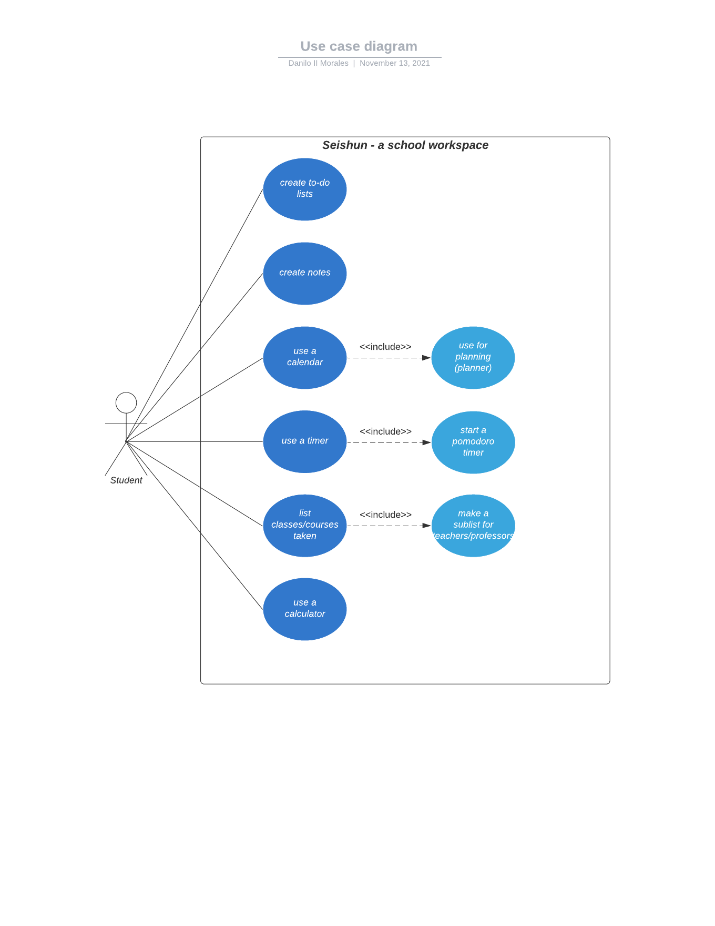

**Use-case descriptions**

Morales

|  |
| --- |
| Use-case Title: Seishun – a school workspace |
| Primary Actor: Students |
| Level: White |
| Stakeholders: Students, Developers |
| Precondition: Students can access the digital workspace |
| Minimal Guarantee: Workspace cannot be accessed |
| Success Guarantees: Students are able to use the workspace and all of its functions |
| Trigger: Student accesses the workspace via web browser |
| Main Success Scenarios:   1. Students are able to create notes for their lessons 2. Students are able to create to-do lists 3. Students are able to create plans and see calendar 4. Students are able to use the included pomodoro timer 5. Students are able to list their classes and instructors 6. Students are able to use a simple calculator included in the workspace |
| Extensions:  1a. Student has lost connection to the website  1a1. Student quits the website  1b. Student’s computer/smartphone has crashed  1b1. Student quits the website  2a. The website is under maintenance  2a1. Student is unable to access the website, and must try again after maintenance |

**Interface Prototype**

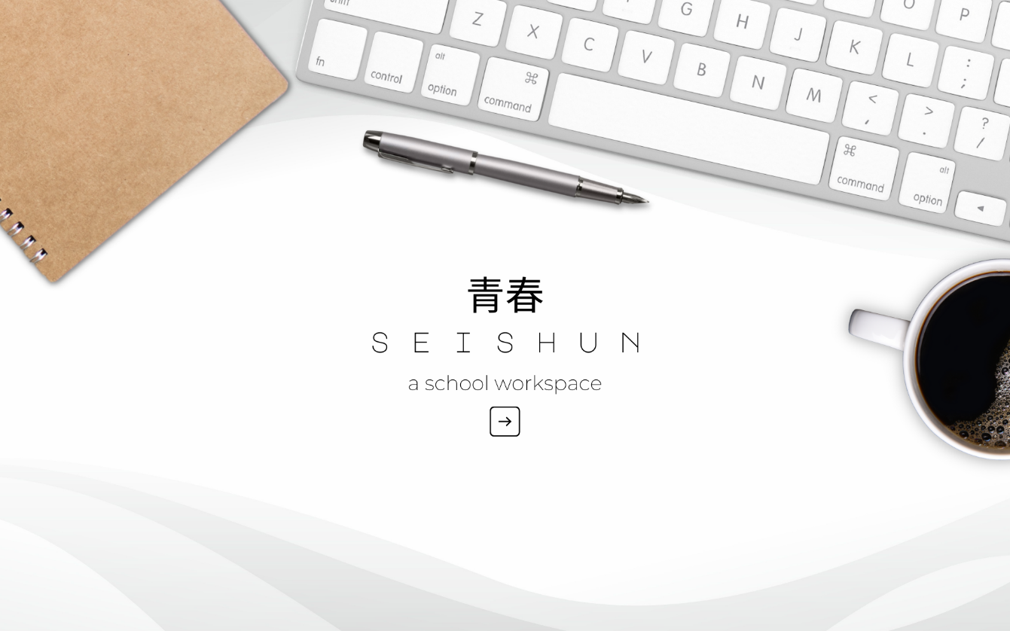

Website Start Page



Website Home Screen

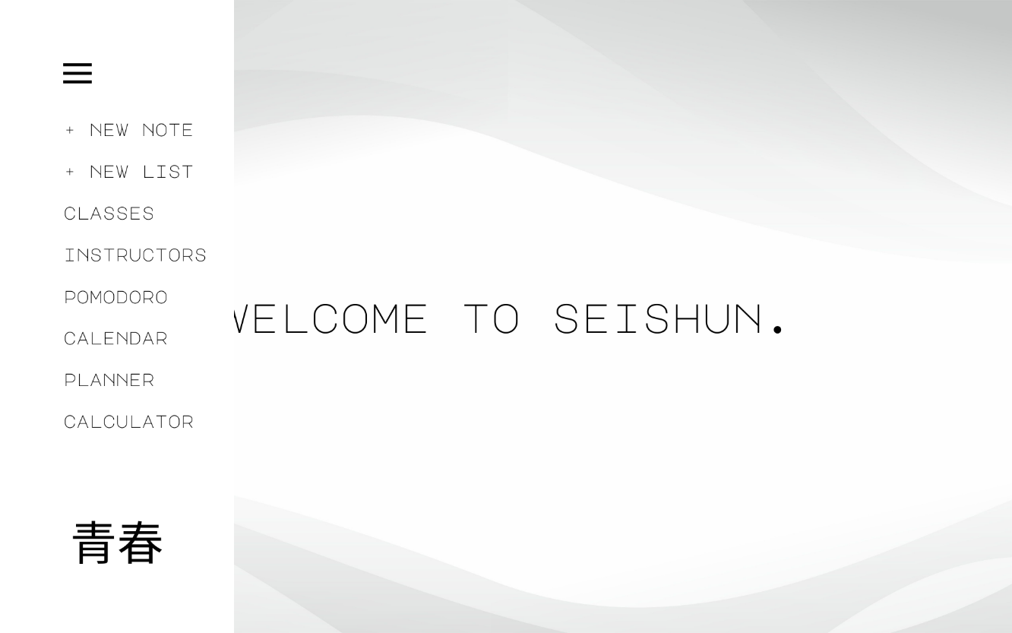

Website Home Screen (Activated Hamburger Button)



New Note Screen



New List Screen

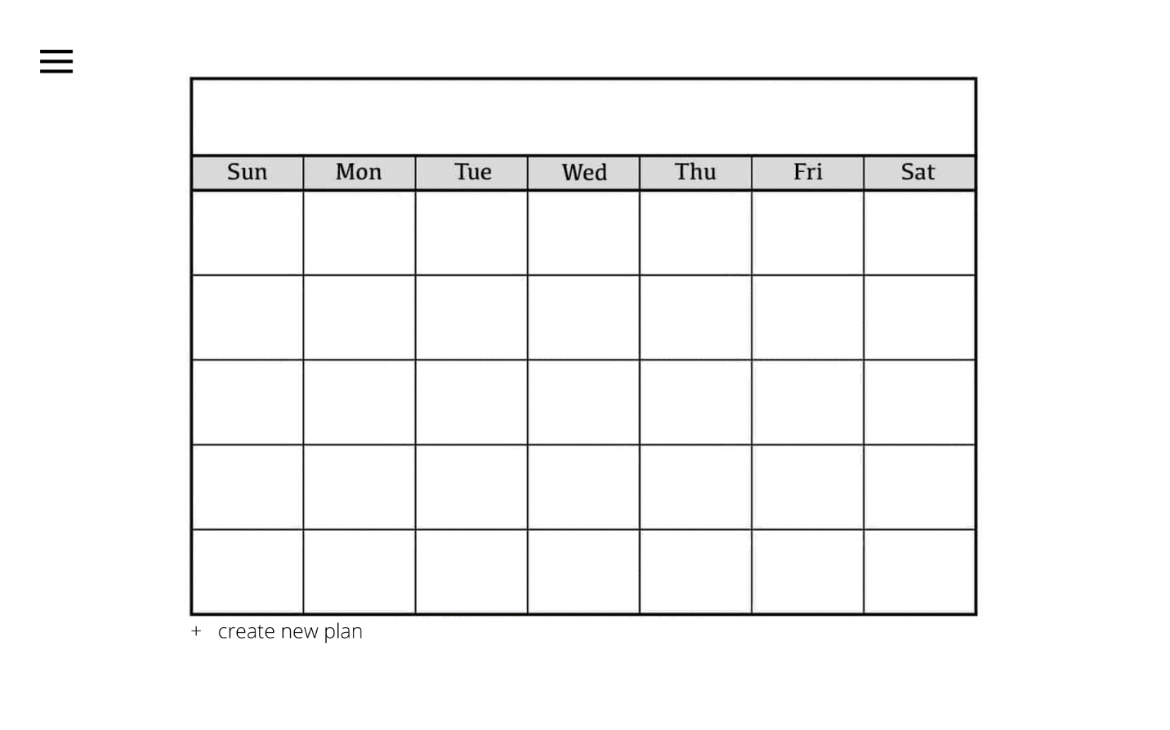

New Calendar and Planner Screen

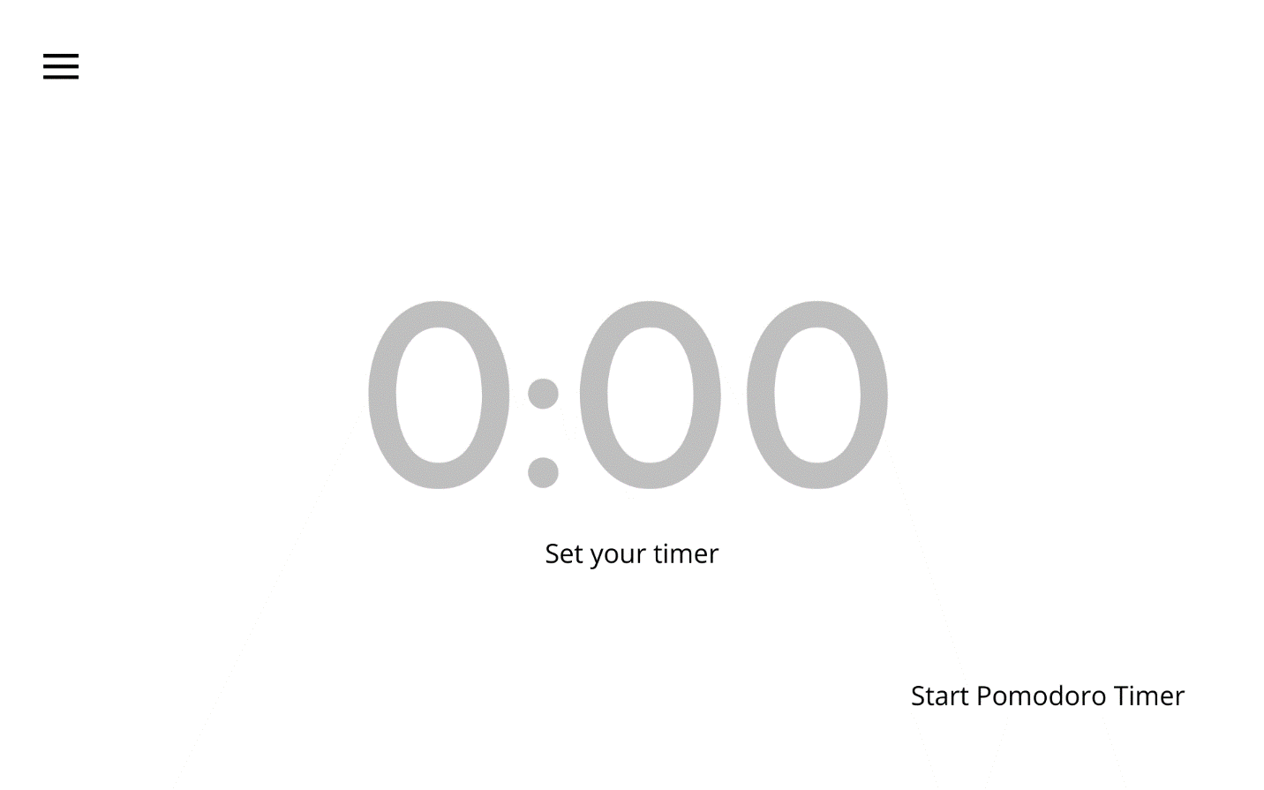

Timer Screen

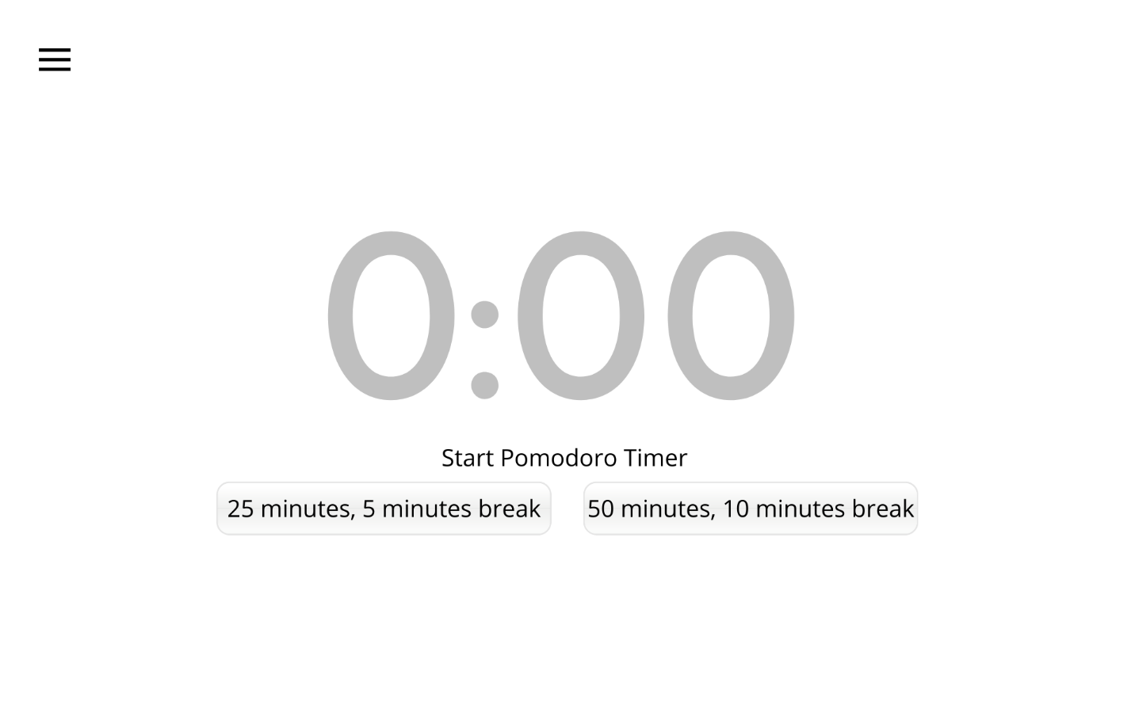

Pomodoro Timer Screen

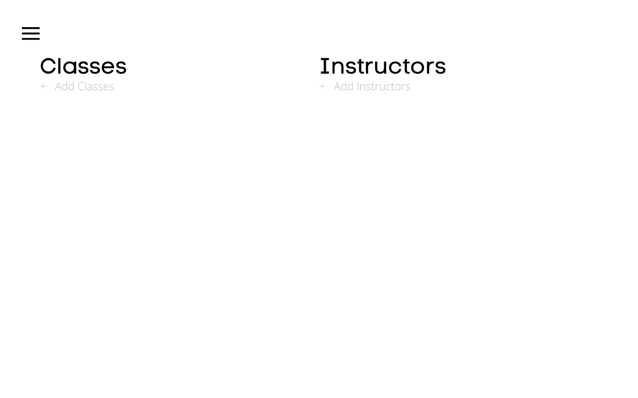

Classes and Instructors Screen

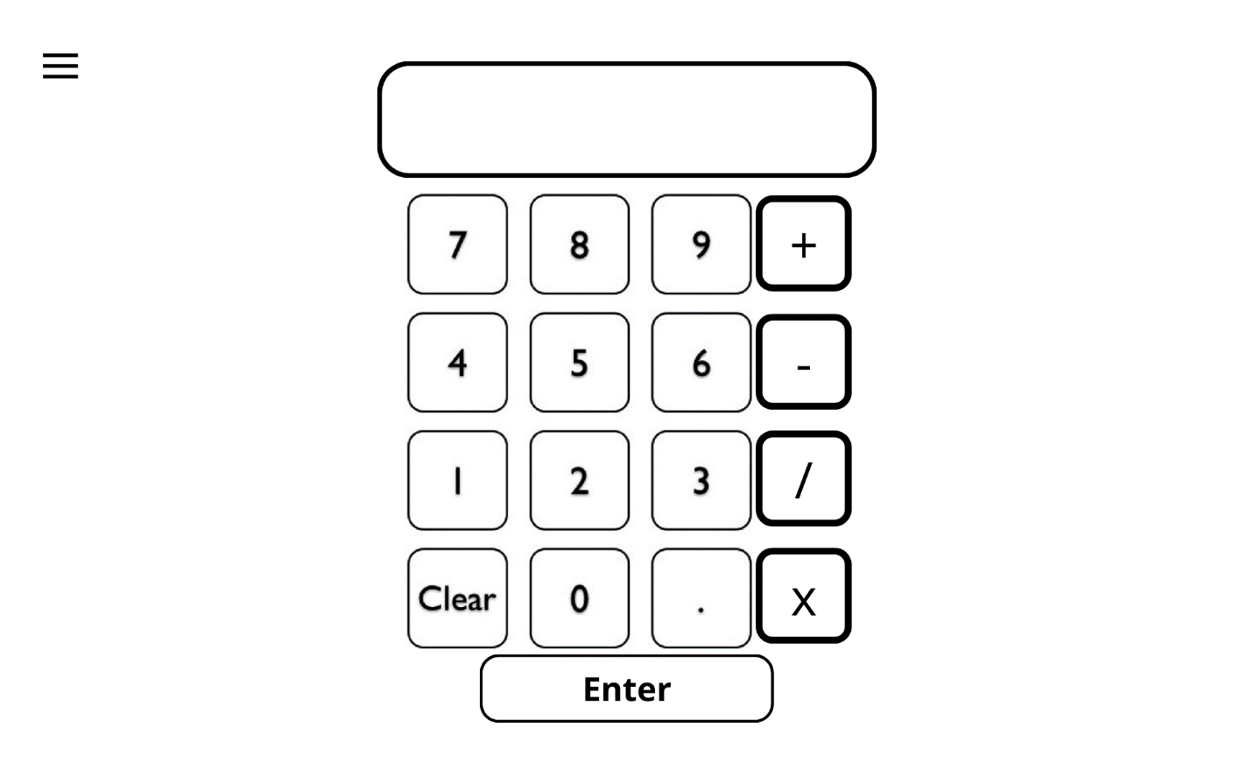

Calculator Screen

Menu Configuration for Interactive Prototype

**Executive Summary**

**Overview**

Seishun – A School Workspace is a digital workspace designed for students. It is an all-in-one workspace where students can type down their notes, list their to-do lists, calculate simple math problems, keep track of classes and instructors, view a calendar and make plans, and use a timer or pomodoro timer.

**Problem**

Students face these problems when using their digital devices:

* Students use a lot of different apps, which can be sometimes confusing.
* Students are disorganized due to the large number of apps that are being used.
* Students are not fully utilizing their digital devices for education.

**Solution**

Seishun – A School Workspace solves these problems by:

* Students will now use one app for all their workspace needs.
* Students can now be more organized when using this app.
* Students can see the capabilities of digital devices for education.

**Highlights**

The application of Seishun – A School Workspace can be ubiquitous. Students of all ages can learn to use this, as this application is user-friendly. They can use it to take digital notes and keep track of their tasks. They can also list down their classes and respective instructors. Seishun – A School Workspace will help a lot of students around the world.

**Keys to Success**

In order to spread the word about Seishun – A School Workspace, we need to do the following:

* We will utilize the internet and social media to advertise about the application.
* Partnering with well-known brands will likely increase the trust in the application.
* Starting from the basic features, we will always listen to the recommendations and suggestions of our consumers when adding new features.